**Query Analysis and Output**

1. Employees whose salary is greater than equal 1000 but not 2000.

SELECT EMP.ENAME AS Employee_Name,DEPT.DNAME AS ,EMP.SAL AS Salary FROM EMP JOIN DEPT ON EMP.DEPTNO = DEPT.DEPTNO WHERE EMP.SAL > 1000 AND EMP.SAL < 2000;

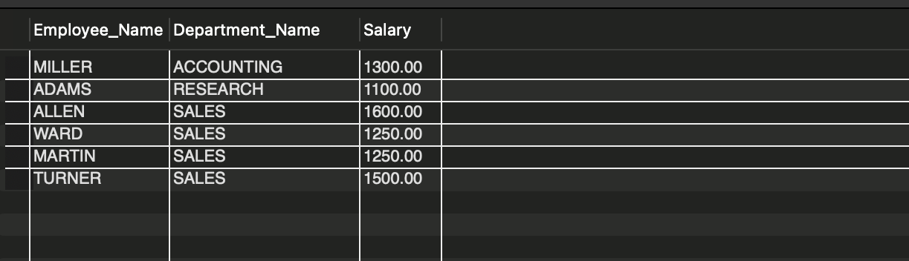

1. Count of employees in department 30 with salary and commission.

SELECT COUNT(*) AS Count FROM EMP WHERE DEPTNO = 30 AND SAL IS NOT NULL AND COMM IS NOT NULL;

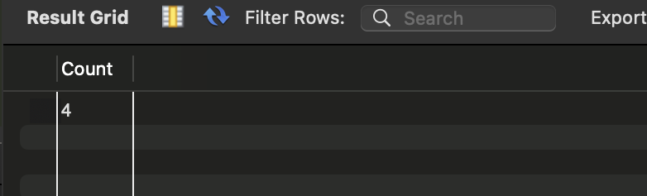

1. Employees whose salary is greater than equal to 1000 and lives in Dallas.

SELECT EMP.ENAME AS Employee_Name,EMP.SAL AS Salary,LOC

FROM EMP JOIN DEPT ON EMP.DEPTNO = DEPT.DEPTNO WHERE EMP.SAL >= 1000 AND DEPT.LOC = 'DALLAS';

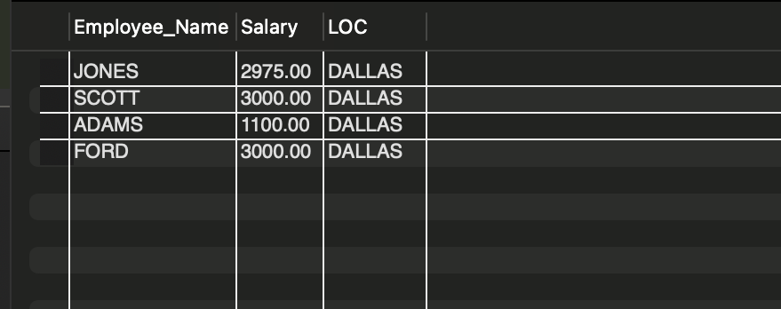

1. Find departments that do not have any current employees.

SELECT DEPT.DNAME AS Department_Name,DEPT.LOC AS Location FROM DEPT LEFT JOIN EMP ON DEPT.DEPTNO = EMP.DEPTNO WHERE EMP.EMPNO IS NULL;

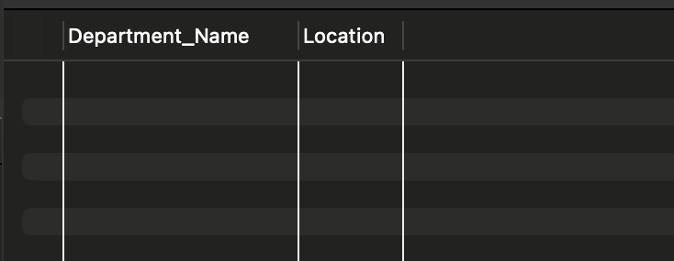

1. Department - wise average salary and employees count.

SELECT DEPTNO AS Department_Number,AVG(SAL) AS Average_Salary,COUNT(EMPNO) AS Employee_CounT FROM EMP GROUP BY DEPTNO;

